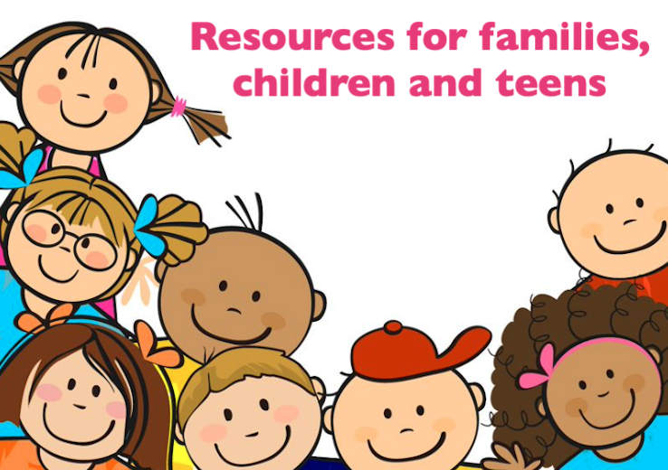

Early Years and Key Stage 1

- Faith at Home - Early years/KS1
- Candle Walk A beautifully-illustrated bedtime prayer book for children,
available as an ebook or hardback.
- Messy Church at Home

Key Stage 2

- Faith at Home ideas - KS2
- Self-isolation kids activities
- Messy Church at Home

Key Stage 3

- Faith at Home ideas - Teens
- The Bible Project Engaging animated videos to help you delve deeper
into the bible.
- Think Ninja An App created for 10-18yr olds aimed at empowering
children and young people build resilience, manage their emotional
health and reach their full potential.

Young Minds

Young Minds have published a lot of useful blogs for young people with advice
for looking after yourself:
- What to do if you’re anxious about coronavirus
- Looking after your mental health while self-isolating
- Tips for creating a routine during self-isolation
- Looking after your mental health while studying from home
- How to look after your mental health in a difficult living environment
- Young people's self-care tips for self-isolation
- Tips for coping with OCD during the coronavirus pandemic

